CHAPTER – 1

TRAVEL/ TRAX TOUR

INTRODUCTION

Tourism is the largest and fastest-growing industry across the world. It is a source of revenue and employment. It also gives the opportunity for people to understand the culture, civilization, and religious aspects of a country. There are many countries whose main source of revenue is Tourism. It is an export that is not visible which earns valuable foreign exchange without any substantial or actual loss of internal resources. Tourism is a unique type of highly labor-intensive industry. It provides different services that are needed as well as expected by the incoming tourists. Tourism is one of the largest industries in terms of money spent by tourists in the countries they visit. The amount received from the Tourism industries sometimes exceeds the Gross National Product of many countries.

India is one of the most popular tourist destinations in Asia and has been successful in attracting domestic and international tourists. India has fascinated many tourists across the globe with her secularism and her culture. The scenic landscape, hill stations, historical sites, architecture and monuments, beaches, and enchanting backwater, places of religious interest make India a preferred destination for tourists from all over the world. Tourism in India has immense potential of developing into a high revenue-generating industry. Better connectivity of transport and communication, improved hospitality services and standard of living and value of money to the tourists from foreign countries have led to an increase in domestic as well as international Tourism.

PURPOSE

* Travel is simply the process of getting from one place to another by some means of transport
* Many people travel from home to work or school by the same means of transport, each day of the working week.
* Travelling on a regular basis to work is called commuting.
* People also travel to take part in leisure activities. Often this is only a short journey to a football pitch, town centre, sports stadium, leisure centre or other facility.
* Also, longer and less regular journeys are made for leisure purposes. These include trips to watch larger sporting events, theatre trips or shopping trips to larger cities
* These may involve private cars or train journeys. Larger groups may decide to travel by coach, such as a group of people travelling to watch an international rugby match in Cardiff.
* Tourism is about a temporary or short-term movement away from the place where a person normally lives and works. The tourist intends to return home at the end of the visit. The length of the visit may be from just one night up to one year
* Most tourist trips are taken as holidays lasting one or two weeks but many business trips last only one night and ‘gap year’ students might be travelling for several months
* Tourism usually, but not always, involves staying away from home. People travelling outside of their home area are called day visitors who are taking part in excursions.Tourism is not only related to leisure although most tourism activity takes place during leisure time. People become tourists

CHAPTER-2

EMPATHY MAP :

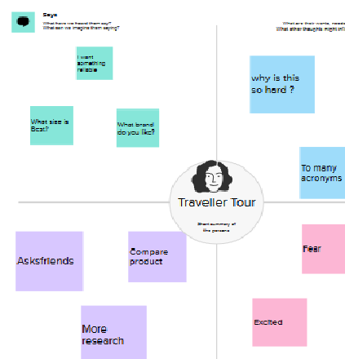

BRAIN STORMING :

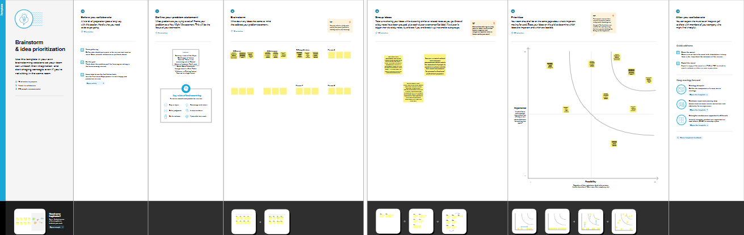

CHAPTER -3





CHAPTER -4

ADVANTAGES:

* There is always money coming in, which is one of tourism's main benefits.
* It is crucial for everyone involved in the travel and tourism industries as well as the overall economy of the nation.
* The historical sites and natural scenery, especially the nation's landmarks, are the main draw for tourists visiting a country.
* People can observe traditions from various cultures and learn about their manners.
* It's possible that tourists did not follow the manners and etiquette in their home countries.
* Tourism has the special ability to bring together people from various nations, cultures, backgrounds, traditions, and ethnicities who are all travelling to have some fun.
* To name a few, these landmarks could be in the form of temples, synagogues, cathedrals, structures, skyscrapers, monuments, parks, and other tourist attractions.
* In some cultures, being impolite involves making noises, showing too much skin, wearing shoes inside, and pointing with your index fingers at the native population.
* When you have the chance to travel to another country and experience its culture, you have the chance to learn about new viewpoints and customs and develop

DISADVANTAGE ;

Tourists can contribute significantly to land pollution because they generate a large amount garbage and waste, the majority of which is non-biodegradable, resulting in a large number of landfills.

* As a result of the large number of tourists visiting their country to observe their unconventional lifestyle and traditions, some countries begin to commercialise their culture.
* Tourists occasionally disrespect the cultures and traditions of the nations and regions they travel to. They might disregard unwritten laws and moral standards that the locals highly value.
* Even though we did mention that tourism increases employment rates, depending on the region, some of these jobs may only be available during certain times of the year.
* Even though tourism creates jobs for locals, the majority of these positions are in the service sector and pay very little.
* These low-wage, low-skill workers have little interest in promotions or moving up the corporate ladder.
* Huge amounts of money made from tourism allow nations to develop only the infrastructure of the tourist destination
* Unfortunately, the nations don't use the money they make from this infrastructure to build and develop other areas that need upkeep and development
* Sometimes, the majority of the locations where tourists are present are owned by foreign companies
* When a nation recognizes that tourism is its main source of income, it often ignores the other diverse industries on which it was founded.

CHAPTER-5

APPLICATION ;

Travel Solution means any online (including Websites) or offline portal, medium or other channel for consumer activities relating to travel or travel-related products, services or other offerings, including shopping, booking, reviewing, searching and redeeming of such travel or travel-related products, offerings and International travel could be considered as a giant mechanical system, with each cog turning in sequence that keeps the entire mechanism moving smoothly through each take-off and landing, or each ship departure and arrival. This is what global interoperability brings. But each time a country introduces a new or independent requirement for traveller COVID-19 health checks, it can introduce friction into the system and risks causing long queues at travel terminals, which can be a health risk themselves, and delay to the much needed recovery of the sector.

A Digital Travel Portal for the pre-travel collection and assessment of travellers COVID-19 status information will also remove the need for lengthy inspections of COVID-19 paperwork during the traveller journey and deliver a practical and scalable solution for COVID-19 health checks as traveller volumes increase. As we look to the future this solution also provides the foundations for digital travel technologies to rapidly mitigate future health risks at the border and can be integrated with other government services for enhanced border security and additional immigration benefits, including as a platform for the efficient digital processing of electronic visas (eVisa).

Travel & Tourism is an integral part of the global economy, and no crisis has demonstrated this better than COVID-19. In 2020, the Travel & Tourism sector lost more than 62 million jobs, with its contribution to global GDP falling by USD $4.5 trillion. Governments have witnessed how the loss of tourism has affected more than just jobs and livelihoods in the sector; it has also had an adverse impact on community development, the environment and wildlife, as well as local and national economies. There is a pressing need to work together to restore livelihoods, recharge economies and reunite people around the world and digital solutions are a vital component that can help accelerate this recovery.

Rarely has collaboration, coordination and partnerships between the public and private sector been more important. International travel could be considered as a giant mechanical system, with each cog turning in sequence that keeps the entire mechanism moving smoothly through each take-off and landing, or each ship departure and arrival. This is what global interoperability brings. But each time a country introduces a new or independent requirement for traveller COVID-19 health checks, it can introduce friction into the system and risks causing long queues at travel terminals, which can be a health risk themselves,**ions with Your Travel Business in M**

CHAPTER-6who really understand the nuances and complexities of the travel customer experience. Our travel user journey and custhave a deep understanding of the end-to-end lifecycle of travel customers, including the specific challenges that businesses in the travel industry face.hiC

s makes us the trusted choice to deliver tailored solutions that will have a real impact on your business.

* Conclusion: some help getting started with your digital transformation? Our team of travel industry experts are on hand to provide the guidance and support you need IN conclusion, we can say that tourism is a very productive activity both for the tourist and the government. As they support each other simultaneously. Also, the government should consider improving the conditions of the country as more and more number of tourist visit their country.
* The future of travel writing is an exciting and dynamic one, with new technologies and media channels creating new opportunities for writers to share their experiences and insights with readers around the world.
* India has the potential to become one of the top tourism centers in the world. With its cultural diversity, historical landmarks, adventure tourism opportunities, medical tourism facilities, and warm hospitality, India has a lot to offer to tourists.offer a range of consulting services th

* solutions that are aligned with your business goals. Our team of experienced developers will work closely with you to capture your unique requirements, and then create a powerful travel solution that is just right for you.

CHAPTER- 7

FUTHURE AND SCOPE :

The tourism sector is projected to contribute $250 Bn to the country's GDP by 2030, generating an employment for 137 Mn individuals, and accrueing $56 Bn in foreign exchange earnings (FEE). The Indian Tourism sector ranks among the fastest-growing economic sectors in the country.

It highlighted that international tourists in India spend 26x more than domestic, hence attracting global visitors is key. India's tourism industry is on track to reach $1 trillion by 2047, with data-led tourism set to be a key driver of growth, according to a report.

The tourism sector is projected to contribute $250 Bn to the country's GDP by 2030, generating an employment for 137 Mn individuals, and accrueing $56 Bn in foreign exchange earnings (FEE). The Indian Tourism sector ranks among the fastest-growing economic sectors in the country.